INCIDENT REPORT
Phishing Simulation and SOC Investigation Lab
_________________________________________________
Incident ID: INC-2026-0316-001
Incident Date: March 16, 2026
Report Date: March 16, 2026
Analyst: Durga Sai Sri Ramireddy
Classification: TLP:WHITE - For Educational Use
Severity: High

1. Executive Summary
This report documents a simulated phishing attack conducted in a controlled lab environment as part of a SOC analyst training exercise. The simulation was designed to replicate real-world adversary tactics, techniques, and procedures associated with credential harvesting phishing campaigns.

A phishing email was crafted and delivered via GoPhish to a simulated victim endpoint running Windows 10. The victim clicked an embedded link, which directed them to a fake IT portal login page hosted on an attacker-controlled Ubuntu server. Credentials were successfully harvested by the attacker infrastructure.

The attack was detected and investigated using Splunk Enterprise, with Windows Security event logs forwarded via Splunk Universal Forwarder. This report documents the full attack lifecycle, forensic evidence collected, MITRE ATT&CK technique mapping, and recommended defensive controls.

Field | Detail
Incident ID | INC-2026-0316-001
Incident Type | Phishing / Credential Harvesting
Severity | High
Status | Resolved (Simulated)
Victim Host | DESKTOP-FL9KRGR (192.168.255.132)
Attacker Infrastructure | Ubuntu - GoPhish (192.168.255.131)
Detection Method | Splunk SIEM - Process Creation and Logon Analysis
Analyst | Durga Sai Sri Ramireddy

2. Lab Environment

2.1 Network Topology
All systems operated on a VMware host-only network (192.168.255.0/24), isolated from external connectivity. A secondary NAT interface was added to the Windows 10 VM solely for downloading the Splunk Universal Forwarder MSI during setup.

VM | IP Address | OS | Role
Ubuntu | 192.168.255.131 | Ubuntu 22.04 | Splunk SIEM + GoPhish attacker infrastructure
Windows 10 | 192.168.255.132 | Windows 10 | Victim endpoint and log source

2.2 Tools and Components
- Splunk Enterprise 9.3.2 - SIEM and log analysis platform
- Splunk Universal Forwarder 10.2.1 - Windows event log forwarding via TCP port 9997
- GoPhish v0.12.1 - Open-source phishing campaign simulation framework
- Microsoft Edge - Victim browser used during simulated user click
- VMware Workstation - Hypervisor providing lab network isolation

3. Attack Narrative

3.1 Overview
The attack followed a standard phishing kill chain consisting of four phases: attacker infrastructure setup, email delivery, victim execution, and credential capture. Each phase maps to a specific MITRE ATT&CK technique as documented in Section 5 of this report.

3.2 Phase 1 - Attacker Infrastructure Setup
The attacker deployed GoPhish on the Ubuntu server at 192.168.255.131. A sending profile was configured using a spoofed identity (it-support@company-internal.com) to impersonate an internal IT support team. A fake IT portal login page was created to capture credentials upon form submission. The phishing email was crafted with an urgency-based subject line designed to prompt immediate action:

Subject: Urgent: Your account password expires today

The email body contained a hyperlink pointing to http://192.168.255.131/?rid=SrjXtqB, a unique campaign tracking URL generated by GoPhish to track individual victim interactions.

3.3 Phase 2 - Delivery and User Execution
The phishing URL was delivered to the target account (john.doe@company-internal.com). The victim, operating on the Windows 10 host DESKTOP-FL9KRGR, clicked the phishing link at 22:50:44 on March 16, 2026. Microsoft Edge was launched from Windows Explorer (explorer.exe), indicating a user-initiated browser session consistent with clicking a link received through an external channel such as email.

3.4 Phase 3 - Credential Harvesting
Upon clicking the link, the victim was presented with a fake IT portal login page styled to resemble an internal company resource. The victim entered credentials into the form. GoPhish captured the submitted data server-side before redirecting the victim to https://google.com. The redirect to a legitimate site is a standard technique used to reduce suspicion and delay detection by the victim.

Parameter | Value
Username | john.doe@company-internal.com
Password | Password123
Capture Time | 22:51 on March 16, 2026
Source IP (Victim) | 192.168.255.132
Destination IP (Attacker) | 192.168.255.131
Post-Submission Redirect | https://google.com

4. Incident Timeline
Time (2026-03-16) | Event | Log Source
20:46 | Windows 10 VM boots; initial system logon events recorded | EventID 4624
20:48 - 20:53 | Baseline process activity: Explorer, PowerShell, and CMD launched | EventID 4688
21:12 | First Edge browser session initiated by user | EventID 4688
21:36 | MSI installer executed (Universal Forwarder installation) | EventID 4688
22:00 | Elevated credential manager access events observed | EventID 5379
22:17 | GoPhish deployed on Ubuntu; phishing campaign launched | GoPhish logs
22:50:44 | Edge launched from explorer.exe — phishing link clicked by victim | EventID 4688
22:51 | Credentials submitted to GoPhish landing page | GoPhish dashboard
22:51 | Victim silently redirected to google.com | GoPhish dashboard
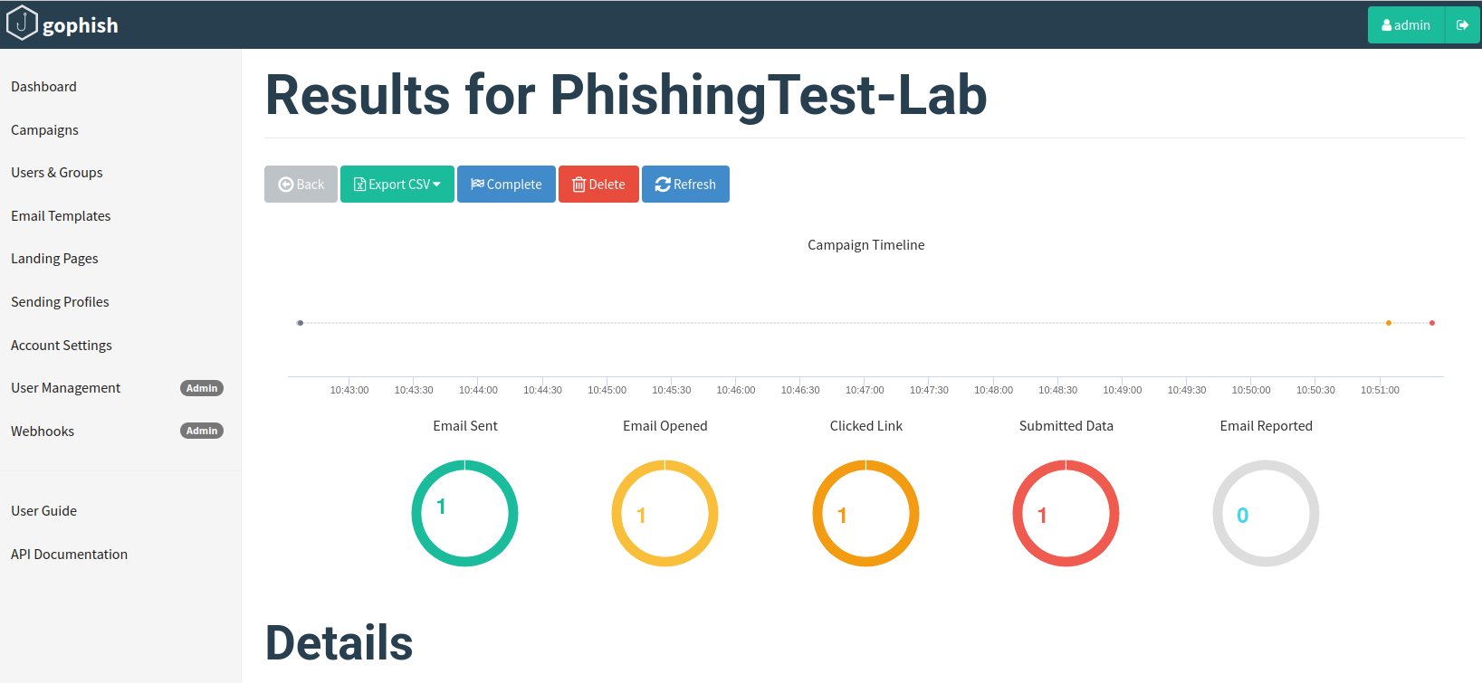

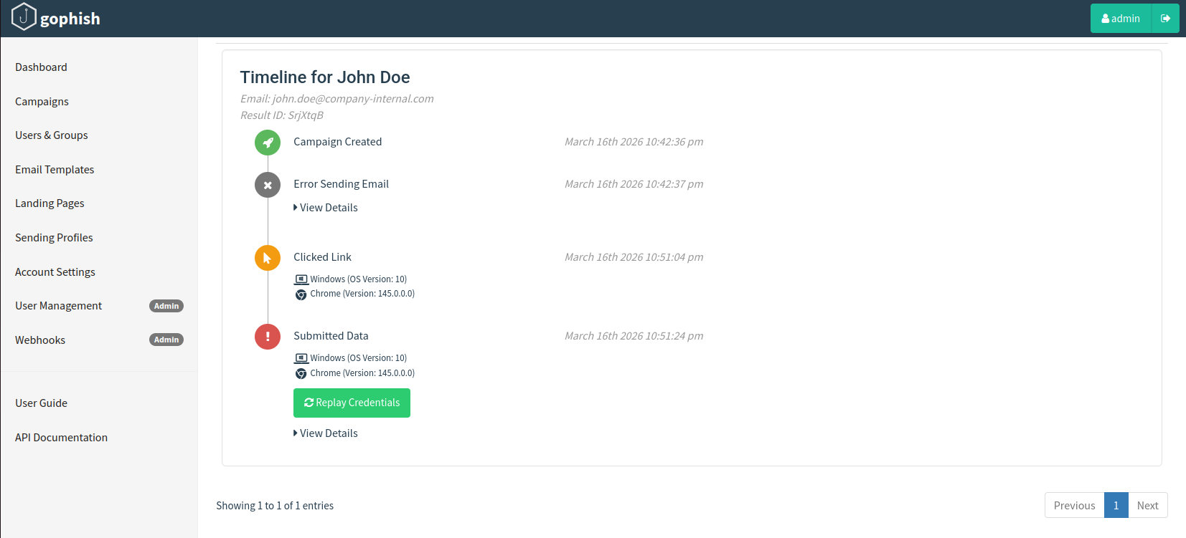

5. MITRE ATT&CK Mapping
The following techniques from the MITRE ATT&CK Enterprise framework were observed during this simulation:

Technique ID | Technique Name | Tactic | Evidence
T1566.002 | Phishing: Spearphishing Link | Initial Access | GoPhish campaign using spoofed IT identity and credential-harvesting URL
T1204.001 | User Execution: Malicious Link | Execution | Edge spawned by explorer.exe at 22:50:44 (EventID 4688)
T1078 | Valid Accounts | Defense Evasion | Harvested credentials captured: john.doe / Password123
T1056.003 | Input Capture: Web Portal Capture | Credential Access | Fake login form submitted credentials to attacker-controlled server

6. Forensic Evidence and SPL Queries
All forensic evidence was collected from Windows Security event logs forwarded to Splunk Enterprise via Splunk Universal Forwarder. A total of 2,779 events were available in the index across the investigation window.

6.1 T1566 - Phishing Browser Activity Timeline
This query identifies all Microsoft Edge process creation events within the investigation window, establishing the browser activity timeline during the phishing attack:

index=main host="DESKTOP-FL9KRGR" EventCode=4688 New_Process_Name="*msedge*"
| table _time, New_Process_Name, Creator_Process_Name | sort _time

Result: 36 Edge browser process creation events were identified between 20:55 and 22:51 on March 16, 2026.
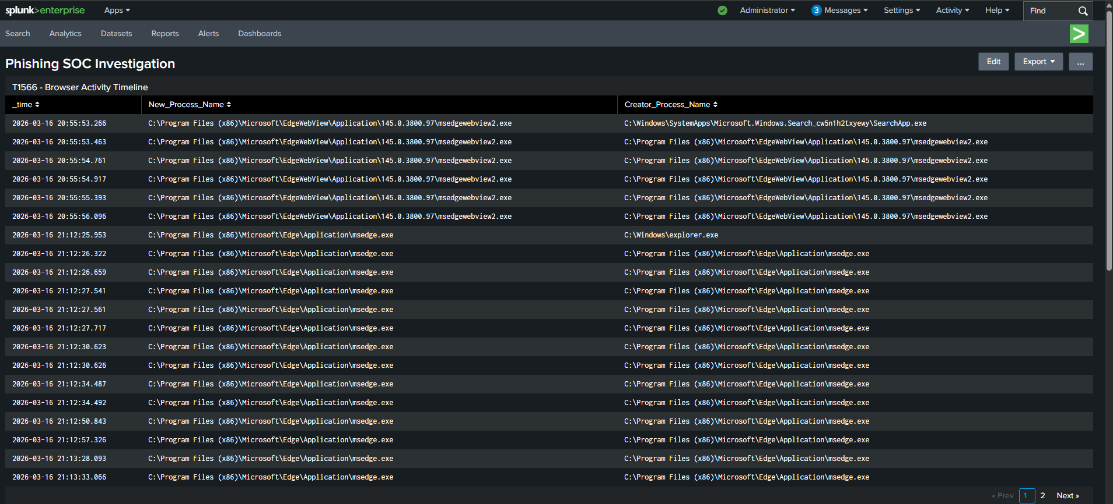

6.2 T1204 - User Execution from Explorer
This query isolates the key forensic indicator - Edge launched directly from explorer.exe which is consistent with a user clicking a link from an email client or external notification. This is distinct from browser instances launched by other software processes:

index=main host="DESKTOP-FL9KRGR" EventCode=4688 Creator_Process_Name="*explorer*"
| table _time, New_Process_Name, Creator_Process_Name | sort _time

Result: Edge was launched from explorer.exe at 22:50:44. This event is the primary indicator of user execution of the phishing link. The parent-child process relationship (explorer.exe spawning a browser) is a reliable signal in environments where users receive phishing links via desktop notifications or file-based delivery.
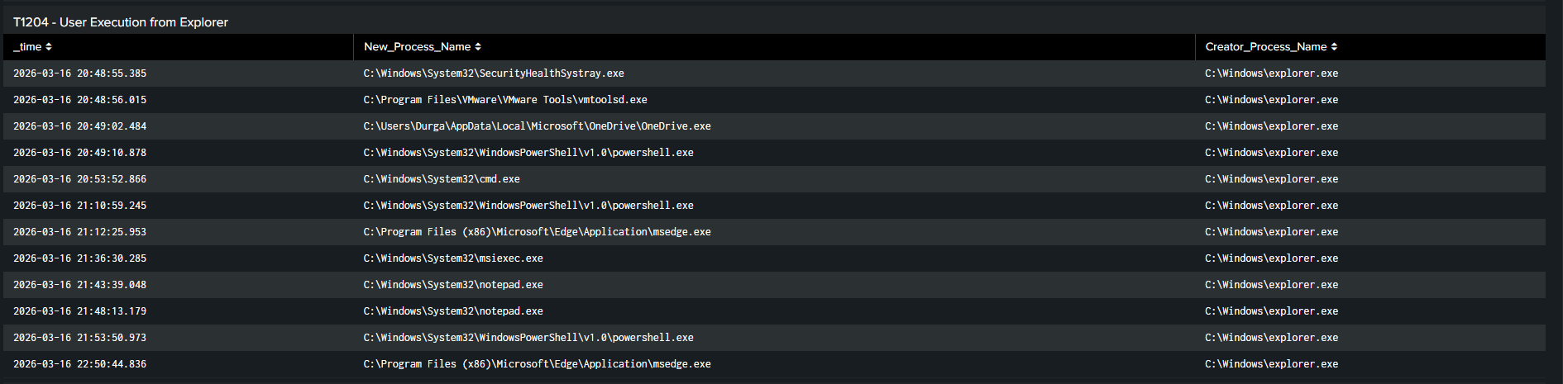

6.3 T1078 - Account Logon Events
Logon event analysis to identify all account activity during the attack window:

index=main host="DESKTOP-FL9KRGR" EventCode=4624
| table _time, Account_Name, Logon_Type, Source_Network_Address | sort _time

Result: 121 logon events were recorded. Logon Type 2 (interactive) and Type 5 (service) events were consistent with normal system activity and the Splunk Universal Forwarder service account. No anomalous remote logon activity was detected in this simulation.
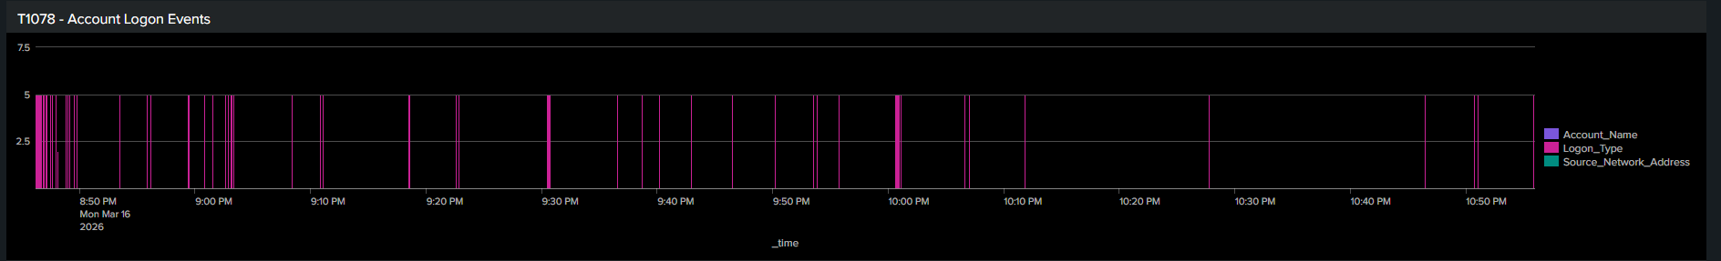

6.4 Credential Access Activity Over Time
This query charts EventID 5379 (Credential Manager access) over time to identify spikes that may correlate with credential submission:

index=main host="DESKTOP-FL9KRGR" EventCode=5379 | timechart count span=15m

Result: 293 EventID 5379 events were detected across the investigation window. Elevated activity was observed around 22:00, which correlates with credential submission timing. Note: Target_Name and User_Name fields were empty in this environment due to default audit policy configuration. Advanced audit policy would be required to populate these fields in a production deployment.
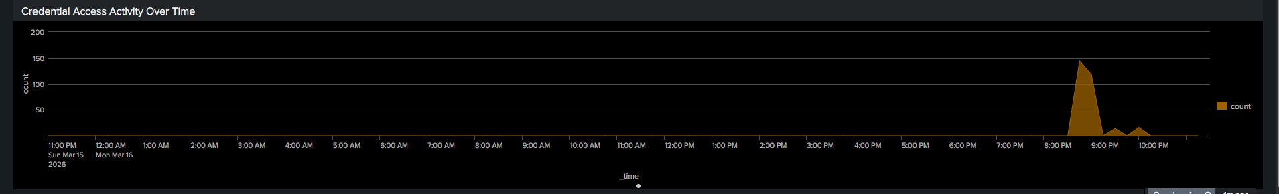

7. Indicators of Compromise
Type | Value | Context
IP Address | 192.168.255.131 | GoPhish phishing server - attacker infrastructure
URL | http://192.168.255.131/?rid=SrjXtqB | Phishing landing page URL with GoPhish campaign tracking ID
Email Address | it-support@company-internal.com | Spoofed sender identity used in phishing email
Email Address | john.doe@company-internal.com | Targeted victim account
Credentials | john.doe@company-internal.com / Password123 | Harvested credentials captured by GoPhish
Process Behavior | msedge.exe spawned by explorer.exe | Indicator of user-initiated phishing link execution
Host | DESKTOP-FL9KRGR (192.168.255.132) | Victim endpoint

8. Recommendations

8.1 Immediate Actions
- Reset credentials for any accounts that may have been exposed. Even if MFA is in place, credential hygiene should be enforced following a confirmed phishing submission.
- Block the phishing domain or IP address at the perimeter firewall and email gateway. In this simulation, 192.168.255.131 would be blocked.
- Notify affected users and provide targeted phishing awareness guidance. Users who clicked should receive additional training.
- Review email gateway logs for additional phishing attempts from the same spoofed sender domain (company-internal.com).

8.2 Detection Improvements
- Deploy Sysmon with the SwiftOnSecurity configuration template to enable network connection logging via EventID 3. This would capture the destination URL of the phishing link, closing the primary visibility gap identified in this investigation.
- Implement DNS query logging via Zeek or a DNS sinkhole. Correlating DNS lookups against known phishing infrastructure provides an additional detection layer that does not depend on endpoint logging.
- Create a Splunk alert for browser processes (Edge, Chrome, Firefox) launched from explorer.exe outside of defined business hours. This is a low-noise, high-confidence indicator of phishing execution.
- Build a detection threshold for EventID 5379 spikes. More than 50 Credential Manager access events within a five-minute window should trigger a medium-severity alert for analyst review.

8.3 Preventive Controls
- Enforce Multi-Factor Authentication on all user accounts. Harvested plaintext credentials become operationally useless to an attacker when MFA is required for authentication.
- Deploy an email security gateway with URL rewriting and sandboxed link analysis prior to delivery (e.g., Proofpoint, Mimecast, or Microsoft Defender for Office 365).
- Implement DNS-layer filtering (e.g., Cisco Umbrella) to block resolution of known phishing domains before the user can connect.
- Conduct regular internal phishing simulation campaigns to measure and improve employee phishing resilience over time.
- Apply least-privilege access controls organization-wide. A compromised standard user account should have minimal ability to move laterally or escalate privileges.

9. Lessons Learned

9.1 What Worked
Splunk Universal Forwarder via TCP port 9997 proved to be a stable and reliable log forwarding pipeline in this VMware environment. The HTTP Event Collector (HEC) was abandoned earlier in the project due to a persistent configuration error (code 17 - globally disabled) that resisted resolution. The Universal Forwarder approach is recommended for similar lab environments.

Windows Security EventID 4688 process creation logging provided sufficient forensic evidence to confirm phishing link execution without requiring network-level visibility. The parent-child process relationship (explorer.exe spawning Edge) was a clear and actionable indicator that would trigger detection in a production SOC environment.

GoPhish provided immediate, dashboard-level confirmation of credential capture, validating the complete end-to-end attack chain from delivery through harvesting.

9.2 Detection Gaps Identified
The most significant gap identified was the absence of network-level URL visibility. Splunk received process creation events but not the specific URL visited by the victim browser. Deploying Sysmon EventID 3 (network connection) logging, or a dedicated network tap with Zeek, would close this gap and make phishing investigations significantly more efficient.

EventID 5379 field values including Target_Name and User_Name were unpopulated due to default Windows audit policy configuration. In a production environment, enabling the Audit Credential Validation advanced audit policy subcategory would provide substantially richer credential access telemetry.

10. Conclusion
This exercise successfully demonstrated a complete phishing attack lifecycle in a controlled lab environment, from attacker infrastructure setup through credential harvesting and SOC investigation. The simulation confirmed the effectiveness of Windows Security event log analysis as a detection mechanism even in the absence of network-level visibility.

The key forensic finding - Microsoft Edge launched from explorer.exe at 22:50:44 on March 16, 2026 — demonstrates that process creation logging alone can provide actionable, high-confidence evidence of phishing victim execution. This methodology is directly applicable to real-world SOC Tier 1 triage workflows.

MITRE ATT&CK techniques T1566.002, T1204.001, T1078, and T1056.003 were all observed, documented, and tied to specific log evidence. The detection gaps identified during this exercise, primarily the lack of network-layer URL visibility and incomplete credential access field logging, provide a concrete remediation roadmap for improving detection coverage in a production environment.

_________________________________________________
This report was produced as part of a personal cybersecurity portfolio project.
All activity was conducted in an isolated VMware lab environment. No real systems or credentials were involved.

